# Kendriya Vidyalaya

Class IV Time -2 hours

I Observe the pictures and answer the questions:

a.

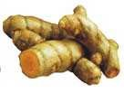

Identify the thing and write its use.

___________________________________________________________ b.



What is the use of this vessel ?

_____________________________________________________

c.  To which country does this belong to ? How did you find ?

____________________________________________________

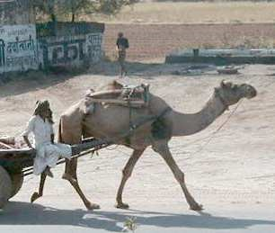

Identify the person who uses it.

_____________________________________________________

d.

Name the state where this is used.

____________________________________________

II. Answer the questions :

1. What does Wahida Prism do as a medical officer on the ship ?

______________________________________________________________________________ ______________________________________________________________________________

2.Why do people cover their heads in Abu Dhabi ?

______________________________________________________________________________ ______________________________________________________________________________

3. How do cows use their teeth?

______________________________________________________________________________ ______________________________________________________________________________

4.What should we do if we have diarrhea and vomiting ?

______________________________________________________________________________ ______________________________________________________________________________

5. Write two sentences about the ‘Desert Oak Tree’.

______________________________________________________________________________

______________________________________________________________________________

Part B

I. Observe the picture and answer the questions:

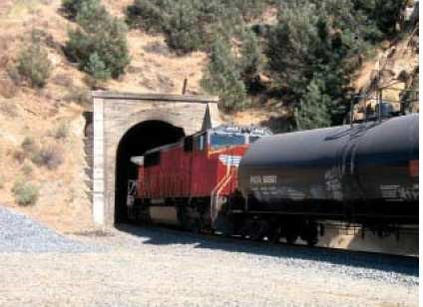

Name the place through which the train passes.

______________________________________________

Identify the painting.

______________________________________

What does he do ?

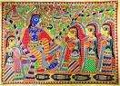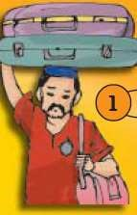

__________________________________________

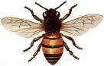What you call them in a group ?

____________________________________________________________

II Answer the questions :

1. Classify the following under the given headings:

( Grapes, Potato, Spinach, Onion)

|  |  |
| --- | --- |
| Veget | ables that |
| Get spoilt quickly | Stay for some days |
|  |  |
|  |  |

1. Why do birds make their nests?

______________________________________________________________________________

______________________________________________________________________________

1. Write any two differences between the houses in

A slum area A bungalow

___________________________________ ________________________________________

___________________________________ _________________________________________

____________________________________ _________________________________________

___________________________________ ________________________________________

III. a) Where do sikhs worship ? What is cooking and eating together in it called ? (3)

______________________________________________________________________________ ______________________________________________________________________________ b) Write any two uses of Water.

______________________________________________________________________________

______________________________________________________________________________

_____________________________________________________________________________ Part C I.Answer these questions:

1. Which part of these plants do we eat? (2)

Cabbage : ___________________________ carrot : ____________________________ II. 1. What are sand dunes ?

__________________________________________________________________________

1. Write any two functions of the worker bee.

______________________________________________________________________________

_____________________________________________________________________________

3.Which are the states that Omana travelled during her journey ?

______________________________________________________________________________

______________________________________________________________________________

4. Why is there so much smoke and noise from the vehicles at the railway level crossing?

______________________________________________________________________________ ______________________________________________________________________________I II . Name the states and locate them on the India Map.

1. Where Basava lived: ____________________________
2. The valley of flower is : __________________________
3. Where Pochampalli saree is made :_________________________
4. Where you live : __________________________
5. Where Khejadi trees are found: _________________________

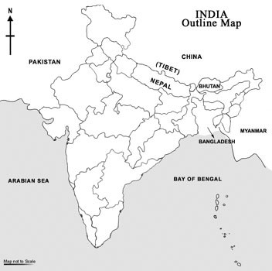

Class IV

# Part A

I Observe the pictures 5 x 1 -5 a. Turmeric . It is used to heal all wounds.

1. Kadai is used to fry some food items,
2. This currency belongs to India.. Because of Gandhiji’s picture d .This is a handsaw used by a carpenter.

e. Camel cart is used in deserts or Rajasthan. 5 x2 -10

II. Answer the questions

a. Wahida Prism makes sure that everybody on the ship stays fit and healthy.

She carries out medical check-ups of all the officers and sailors She checks if cleanliness is maintained on the ship.

She trains everybody to get ready for any medical emergency. ( any 2) b .People cover their heads in Abu Dhabi as the weather is very hot and to protect themselves from the hot sun.

1. Cows have short front teeth for snipping grass. The teeth on the sides are large and flat for chewing the grass.
2. When we have diarrhoea and vomiting, we lose a lot of water from our body So we should drink boiled and cooled water in which a teaspoon of sugar and a pinch of salt is mixed.
3. Desert Oak tree is found in Australia. It grows very tall. It has very few leaves. The roots go deep into the ground till they reach water. The water is stored in the tree trunk.

# Part B

I. Observe the pictures 4 x 1 = 4 a. .The train passes through a tunnel.

1. This is Madhubani painting showing designs of human beings.
2. The porter carries our luggages.
3. They are called swarm of bees.

II Answer the questions 3 x 2 = 6

1. Vegetables that

Get spoilt quickly stay for some days

Grapes Potato Spinach Onion

1. Birds make their nests to lay eggs, hatch them and to look after the young ones .
2. Differences between the (any 2)

The house in slum area A Bungalow

1. Only one room to sit,sleep,cook Separate rooms to sit, sleep, cook and wash and wash.
2. Only one public-tap to get water Many taps available in each house. for many houses.
3. Only one toilet for many houses. Two or three toilets in each house.

III. Recipe for Potato chat 1 x 5 = 5

1. Sikhs worship in Gurudwara. 2. a Langar b Bathing & Cooking

Part C

I.. Answer the following 2 x 2 = 4

1. Cabbage- leaves carrot – root

Answer the questions. 3 x 2 = 6

1. Mountains made of sand are called sand dunes.

2 Functions of the worker bees: They look after the baby bees, They make the hive.

The collect the nectar from the flowers. They work the whole day. ( any 2) 3. The states the Omana travelled during her journey are Gujarat, Maharashtra.

Karnataka, Goa and Kerala.

4. Because drivers do not switch off engines.

II (Naming the states – 2 ½ Locating the states -2 ½ ) 1 x 5 = 5

1. Where Basava lived : Karnataka
2. The valley of flower is : Uttaranchal or Uttarkhand
3. Where Pochampalli saree is made : Andhra Pradesh
4. Where you live : Tamilnadu
5. Where Khejadi trees are found : Rajasthan